Triangular Rotunda
# Source: AI Source: Provided by: [Data Path: Persons Table -> ID Column: 1, Name_En Column: Motasem Essam] -> From: [ChatGPT] on [7/25/2026]
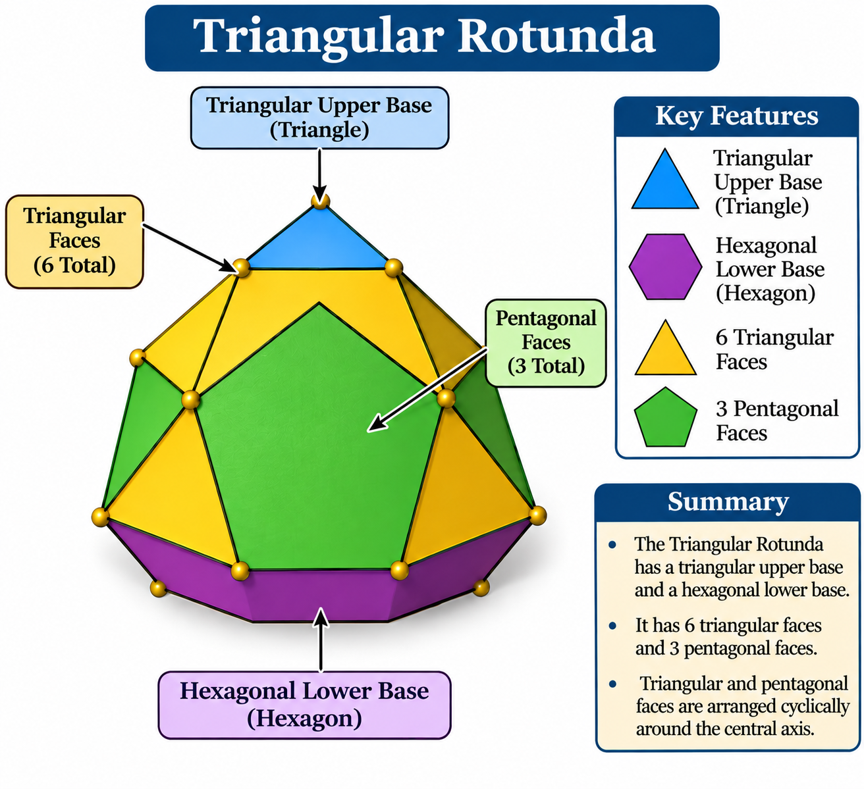

Definition
# Source: AI Source: Provided by: [Data Path: Persons Table -> ID Column: 1, Name_En Column: Motasem Essam] -> From: [ChatGPT] on [7/25/2026]
A Triangular Rotunda is a generalized member of the Rotunda family, characterized by a triangular upper base, a hexagonal lower base, and a band of alternating triangular and pentagonal lateral faces.
It follows the general rotunda construction, in which an $n$-sided polygon is connected to a parallel $2n$-sided polygon through triangular and pentagonal faces.
Important: Unlike the Pentagonal Rotunda (J6), the Triangular Rotunda is not one of the 92 convex Johnson solids. The classical regular-faced rotunda is the Pentagonal Rotunda; other generalized rotundas may require distorted lateral faces. <Cite refs={["turn932124search0","turn932124search12","turn932124search13"]}/>
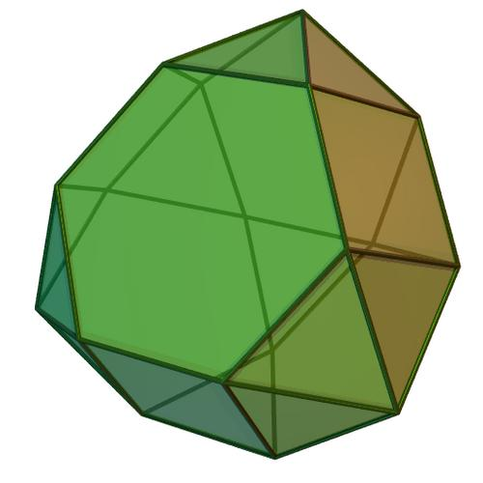

Geometric Structure
# Source: AI Source: Provided by: [Data Path: Persons Table -> ID Column: 1, Name_En Column: Motasem Essam] -> From: [ChatGPT] on [7/25/2026]
The Triangular Rotunda consists of:
- Upper Base: A triangular polygon.
- Lower Base: A hexagonal polygon, rotated relative to the upper base.
- Triangular Faces: Six triangular lateral faces.
- Pentagonal Faces: Three pentagonal lateral faces.
- Alternating Arrangement: Triangular and pentagonal faces are arranged cyclically around the central axis.
<Cite refs={["turn932124search12","turn932124search1"]}/>

Face Composition
# Source: AI Source: Provided by: [Data Path: Persons Table -> ID Column: 1, Name_En Column: Motasem Essam] -> From: [ChatGPT] on [7/25/2026]
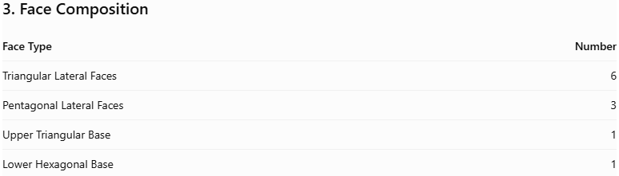
Face Type | Number
Triangular Lateral Faces | 6
Pentagonal Lateral Faces | 3
Upper Triangular Base | 1
Lower Hexagonal Base | 1
Total Faces | 11

Mathematical Properties
# Source: AI Source: Provided by: [Data Path: Persons Table -> ID Column: 1, Name_En Column: Motasem Essam] -> From: [ChatGPT] on [7/25/2026]

Property | Value
Total Faces (F) | 11
Total Edges (E) | 21
Total Vertices (V) | 12
Upper Base | Triangle
Lower Base | Hexagon
Symmetry Group | $$C_{3v}$$
Rotational Symmetry | Order 3
Geometric Type | Generalized Rotunda
Johnson Solid Number | None
General Rotunda Formulas:
For an $n$-gonal Rotunda:
$$F=3n+2, E=7n, V=4n$$
For the Triangular Rotunda, $n=3$:
$$F=11, E=21, V=12$$
Euler's Polyhedron Formula:
$$V-E+F=2$$
$$12-21+11=2$$
<Cite refs={["turn932124search12","turn932124search1"]}/>

Geometric Characteristics
# Source: AI Source: Provided by: [Data Path: Persons Table -> ID Column: 1, Name_En Column: Motasem Essam] -> From: [ChatGPT] on [7/25/2026]
- Triangular Upper Base: Its upper base consists of three sides and three vertices.
- Hexagonal Lower Base: Its lower base consists of six sides and six vertices.
- Alternating Lateral Faces: Six triangular faces and three pentagonal faces form the lateral structure.
- Threefold Rotational Symmetry: Its arrangement repeats after a rotation of ${120}^{∘}$.
- Rotunda Construction: It follows the general arrangement of triangular and pentagonal lateral faces.
- Generalized Polyhedron: It belongs to the generalized Rotunda family rather than the classical regular-faced Johnson solids.

Construction of Triangular Rotunda

Geometric Instruments Used
# Source: AI Source: Provided by: [Data Path: Persons Table -> ID Column: 1, Name_En Column: Motasem Essam] -> From: [ChatGPT] on [7/25/2026]
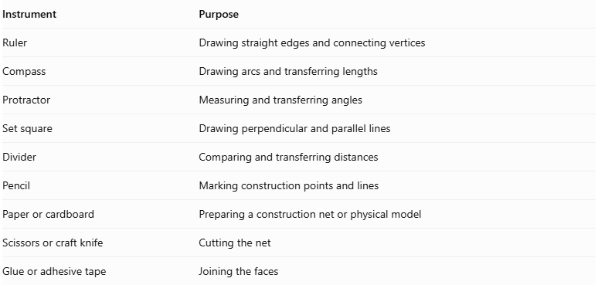
Instrument | Purpose
Ruler | Drawing straight edges and connecting vertices
Compass | Drawing arcs and transferring lengths
Protractor | Measuring and transferring angles
Set square | Drawing perpendicular and parallel lines
Divider | Comparing and transferring distances
Pencil | Marking construction points and lines
Paper or cardboard | Preparing a construction net or physical model
Scissors or craft knife | Cutting the net
Glue or adhesive tape | Joining the faces

Instrument-Based Construction Procedures
# Source: AI Source: Provided by: [Data Path: Persons Table -> ID Column: 1, Name_En Column: Motasem Essam] -> From: [ChatGPT] on [7/25/2026]
No coordinate-based construction
The construction uses geometric instruments, polygon geometry, measured lengths, angles, and face-to-face edge matching. It does not use coordinates, coordinate axes, or coordinate equations.

Construct the Upper Triangular Base
# Source: AI Source: Provided by: [Data Path: Persons Table -> ID Column: 1, Name_En Column: Motasem Essam] -> From: [ChatGPT] on [7/25/2026]
- Draw a straight line segment using a ruler.
- Set the compass to the required side length.
- Construct an equilateral triangle using intersecting compass arcs.
- Join the three vertices.
- Label the vertices $A$, $B$, and $C$.

Construct the Lower Hexagonal Base
# Source: AI Source: Provided by: [Data Path: Persons Table -> ID Column: 1, Name_En Column: Motasem Essam] -> From: [ChatGPT] on [7/25/2026]
- Draw a circle using a compass.
- Mark six consecutive points on its circumference by stepping the circle's radius around it.
- Join the six points using a ruler.
- Verify that the resulting regular hexagon has six equal sides.
- Label its vertices $D_{1},D_{2},D_{3},D_{4},D_{5},D_{6}$.

Construct the Six Triangular Lateral Faces
# Source: AI Source: Provided by: [Data Path: Persons Table -> ID Column: 1, Name_En Column: Motasem Essam] -> From: [ChatGPT] on [7/25/2026]
- Identify the six triangular faces required by the generalized rotunda arrangement.
- Draw each triangle using a ruler, compass, and protractor as required by the selected model.
- Match their edges to the appropriate edges of the upper and lower base arrangements.
- Check that each lateral triangle joins the correct neighboring faces.

Construct the Three Pentagonal Lateral Faces
# Source: AI Source: Provided by: [Data Path: Persons Table -> ID Column: 1, Name_En Column: Motasem Essam] -> From: [ChatGPT] on [7/25/2026]
- Draw three pentagonal faces.
- Determine their side lengths and angles from the intended rotunda model.
- Position them alternately within the lateral face arrangement.
- Match each pentagon's edges to the adjacent triangular faces.
- Verify that no unmatched boundary edge remains except those belonging to the two bases.

Arrange the Faces
# Source: AI Source: Provided by: [Data Path: Persons Table -> ID Column: 1, Name_En Column: Motasem Essam] -> From: [ChatGPT] on [7/25/2026]
- Position the triangular upper base and hexagonal lower base parallel to each other.
- Arrange the six triangular and three pentagonal lateral faces between the bases.
- Check that corresponding edges have matching lengths.
- Verify that the faces meet without gaps or unintended overlaps.

Assemble the Solid
# Source: AI Source: Provided by: [Data Path: Persons Table -> ID Column: 1, Name_En Column: Motasem Essam] -> From: [ChatGPT] on [7/25/2026]
- Prepare a net or separate face pieces using the verified edge arrangement.
- Cut out the faces.
- Fold the connecting edges where a net is used.
- Join the matching edges.
- Close the upper and lower bases.
- Inspect the finished model from several directions.
Construction accuracy: The pentagonal faces must be shaped to fit the selected model. Simply drawing three regular pentagons and six equilateral triangles around a triangle and hexagon does not guarantee a geometrically valid closed rotunda.

Key Points
# Source: AI Source: Provided by: [Data Path: Persons Table -> ID Column: 1, Name_En Column: Motasem Essam] -> From: [ChatGPT] on [7/25/2026]
- Upper Base: Triangle.
- Lower Base: Hexagon.
- Triangular Lateral Faces: 6.
- Pentagonal Lateral Faces: 3.
- Total Faces: 11.
- Total Edges: 21.
- Total Vertices: 12.
- Rotational Symmetry: Order 3.
- Classification: Generalized Rotunda.
- Johnson Solid: Not a Johnson solid.

Main Classification
# Source: AI Source: Provided by: [Data Path: Persons Table -> ID Column: 1, Name_En Column: Motasem Essam] -> From: [ChatGPT] on [7/25/2026]
Solid Geometry
└── Types of Solids
└── Rotunda
└── Types of Rotundas
└── Triangular Rotunda

Conclusion
# Source: AI Source: Provided by: [Data Path: Persons Table -> ID Column: 1, Name_En Column: Motasem Essam] -> From: [ChatGPT] on [7/25/2026]
The Triangular Rotunda is a generalized rotunda characterized by its triangular upper base, hexagonal lower base, and alternating arrangement of six triangular and three pentagonal lateral faces. Its combinatorial structure has 11 faces, 21 edges, and 12 vertices, with threefold rotational symmetry.

